Assignment: Programs on For Loop

# Aim: Write python programs using for loop

# 1. Write a python program using a for loop that asks the user for a number, and prints the digits of the number on screen

## Source Code:

# Get input from user

num = int(input("Enter a number: "))

# Initialize empty string

string = ""

# Loop through digits in num and add to string

for digit in str(num):

string += digit + " "

print(string)

## Output:



# 2. Write a python program to perform addition of 2 numbers till the user wishes

## Source Code:

# Decides whether program will restart or terminate

cont = "yes"

# Infinite for loop

for _ in iter(int, 1):

# If cont is yes calculate sum of 2 numbers

if cont.casefold() == "yes":

num1 = int(input("Enter first number: "))

num2 = int(input("Enter second number: "))

ans = num1 + num2

print("The sum of two numbers is", ans)

cont = input("Do you want to continue? (yes/no): ")

# Else terminate the program

else:

print("This program is now closed")

break

## Output:

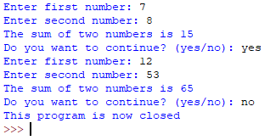

# 3. Write a python program to calculate factorial of a number

## Source Code:

# Get input from user

num = int(input("Enter a number: "))

# Initialize factorial to num

factorial = num

# Multiply i to factorial [i = 1, 2, ..., (num – 1)]

for i in range(1, num):

factorial *= i

# Print number and factorial

print("{0}! is {1}".format(num, factorial))

## Output:



# 4. Write a python program to check number is prime or not

## Source Code:

# Required for math.sqrt()

import math

# Get input from user

num = int(input("Enter a number: "))

# Loop from 2 till root of num

for divisor in range(2, (int(math.sqrt(num)) + 1)):

# If remainder zero then num is not prime. Break

if num % divisor == 0:

print("Number is not prime")

break

else:

print("Number is prime")

## Output:

### Case 1: Number is prime



### Case 2: Number is not prime



# 5. Write a python program to check whether number is Armstrong or not

## Source Code:

# Get input from user

num = int(input("Enter a number: "))

# Initialize sumofcubes to 0

sumofcubes = 0

# Loop through every digit in num

for digit in str(num):

# Add cube of digit to sumofcubes

sumofcubes += int(digit) ** 3

# Check if number is Armstrong number

if sumofcubes == num:

print("This is an Armstrong number")

else:

print("This is not an Armstrong number")

## Output:

### Case 1: Number is Armstrong



### Case 2: Number is not Armstrong



# 6. Write a python program to display prime numbers between 1 to 100

## Source Code:

# Required for math.sqrt() function

import math

for num in range(1, 101):

# Initilize divisor to 2 and factor to 1

divisor = 2

factor = 0

for divisor in range(2, int(math.sqrt(num))):

# Check if remainder is zero

if num % divisor == 0:

# Increment factor and break

factor += 1

break

# Increment divisor

divisor += 1

# Print num if prime

if factor == 0 and num != 1:

print(num)

## Output:

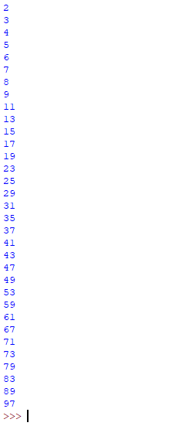

# 7. Write a python program to check whether number is palindrome or not

## Source Code:

# Get input from user

num = int(input("Enter a number: "))

# Initialize rev as empty string

rev = ""

# Calculate reverse of number

for digit in str(num):

rev = digit + rev

# Check if number is same as reverse

if num == int(rev):

print("{0} is a palindrome".format(num))

else:

print("{0} is not a palindrome".format(num))

## Output:

### Case 1: Number is a palindrome



### Case 2: Number is not a palindrome



# 8. Write a python program to check whether a number is perfect or not

## Source Code:

# Get input from user

num = int(input("Enter a number: "))

# Initialize additon and divisor to 0 and 1 respectively

addition = 0

# Add the factors of num and store in addition

for divisor in range(1, num):

if(num % divisor == 0):

addition += divisor

# If addition is equal to the number it is a perfect number

if(addition == num):

print("{0} is a perfect number".format(num))

else:

print("{0} is not a perfect number".format(num))

## Output:

### Case 1: Number is a perfect number



### Case 2: Number is not a perfect number



# 9. Write a program to print factors of a number

## Source Code:

# Get input from user

num = int(input("Enter a number: "))

# Print the factors of num

print("Factors of {0} are:".format(num), end = " ")

for divisor in range(1, (num + 1)):

if(num % divisor == 0):

print(divisor, end = " ")

## Output:



# 10. Write a program to reverse a number

## Source Code:

# Get input from user

num = int(input("Enter a number: "))

# Initialize rev as empty string

rev = ""

# Calculate reverse of number

for digit in str(num):

rev = digit + rev

# print reverse of the original number

print("Reverse of {0} is {1}".format(num, rev))

## Output:

